Name: Rosemary Agbozo

Practical Activity 5

ANSWER

In order to start anything at all, I went to the Server manager, went to tools and selected Active Directory Users and Computers. It opened a window for me.

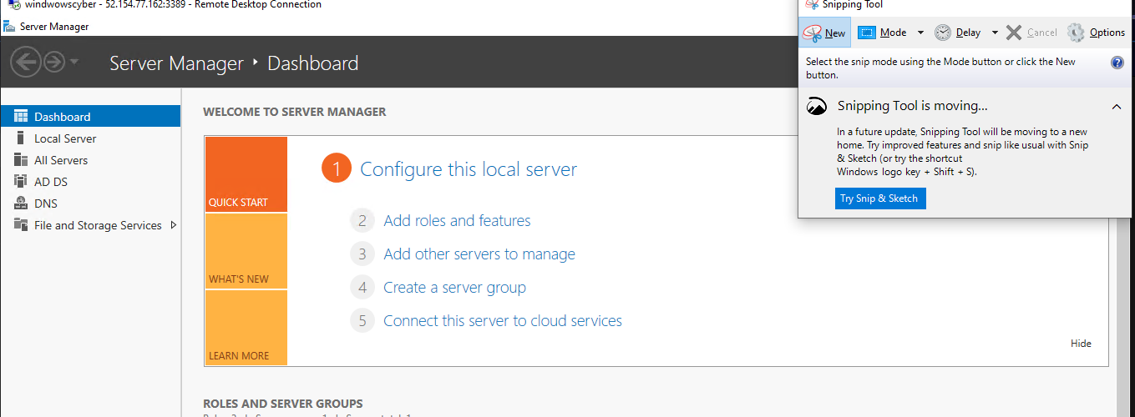

Figure 1 Server Manager opened

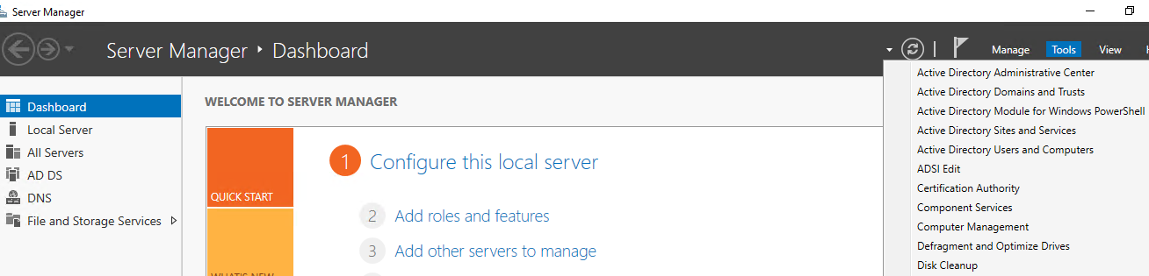

Figure 2 Navigating to Active directory Users and Computers

CREATING HEADQUATERS AND 2 SALES LOCATIONS

When in the active directory users and computers, I right-click on my local server (rosamarie.local) and I select add. Then I selected ‘Organizational unit’, then I name it and create. I used this to first create the main company, which is ‘Carmax car dealership’. Then I used this method to create 3 organizational units (the headquarters and the 2 sales location) in the car dealership organization.

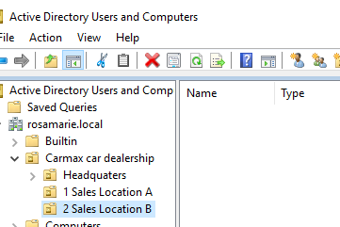

Figure 3 Creating Headquarters and sales locations

Populating the headquarters and the sales locations.

I used the same method I used to create the organizational units to create the departments/units and offices for the Headquarters and the 2 sales locations. Also, creating the groups for each of the units. To create the group, I went into the unit, right-click, select new, then group. And I filled in the necessary details.

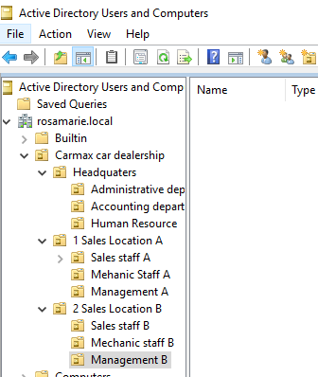

Figure 4 Creating organizational units for Headquarters and Sales location

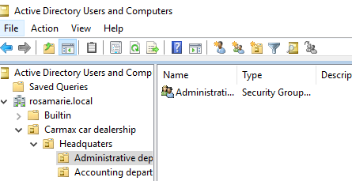

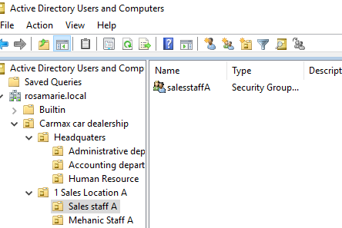

Figure 5 Creating groups for the various users in the departments

Adding dummy users under each unit/ groups created.

Creating 1 dummy user under each department. Added them to the various departments by right-clicking on the user and selecting add to group. Then I search for the group I want to move them to.

Creating a new user steps I followed.

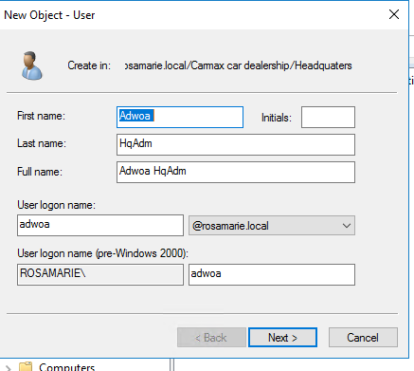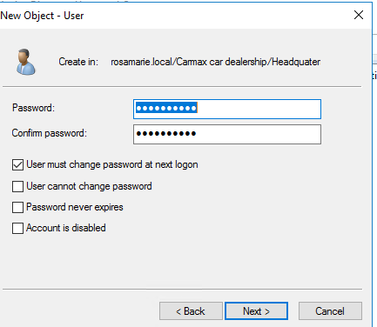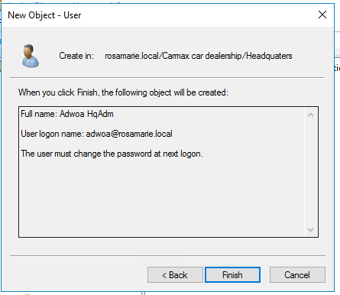

I added the users to their respective groups successfully. 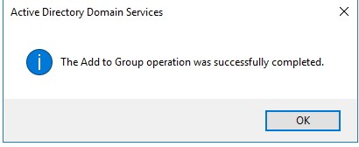

Proof that members are in the groups/ departments they are supposed to be in.

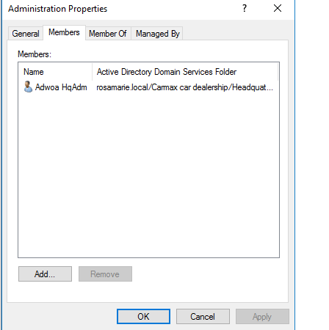

Figure 6 Adwoa is a member of the Administration department

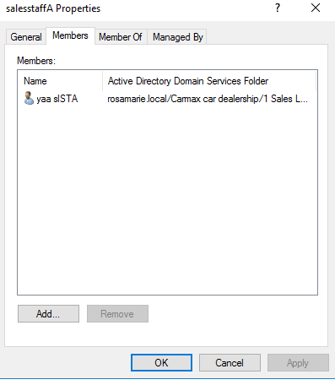

Figure 7 Yaa is a member of the sales staff department

User promoted.

If a user is promoted from the Sales staff in sales location A, to Administration in Headquarters, below is what I will do.

First, I will remove the user, Yaa, from being a member of the sales staff in sales location A.

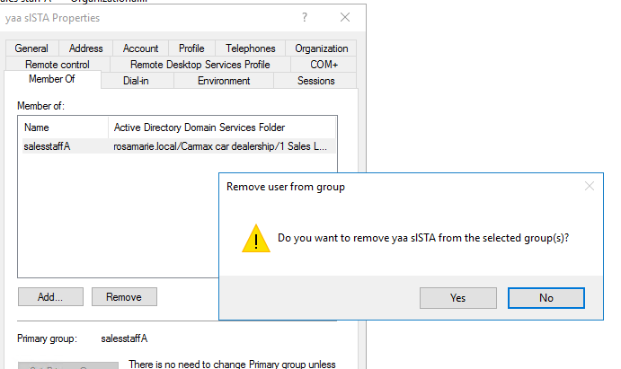

Figure 8 Removing Yaa from sales staff

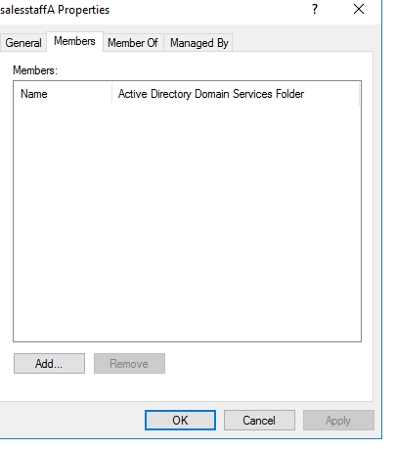

Figure 9 Proof Yaa is no more in sales

Then I will move Yaa to the headquarters Organizational unit, with the move (when you right-click)

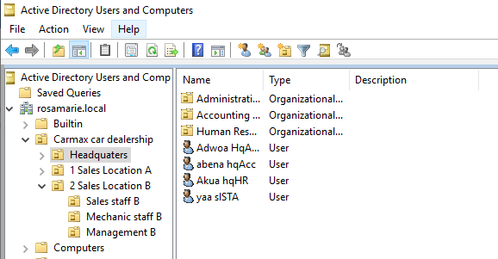

Then I will add Yaa to the Administration unit group. There, she will be under all the privileges of the administration department.

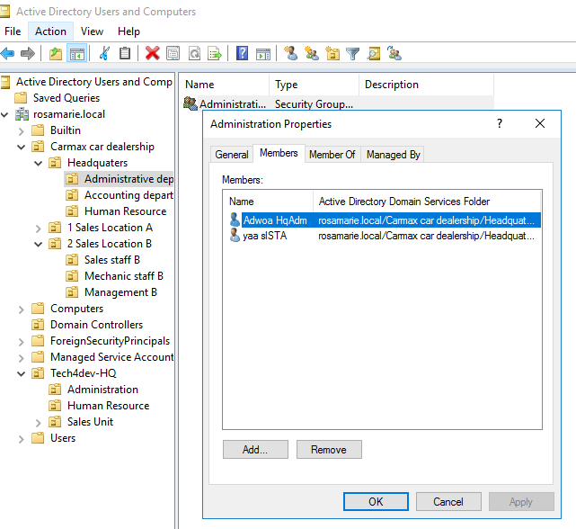

Figure 10 Yaa under Administration member

User on leave.

Assuming David from the mechanics staff in sales location B goes on a one-month leave, here is how I will handle it.

First, I will go to his Account, right-click and disable account. Once I do this, his account will be inactive (the status will be inactive). This is only temporary, once he returns, I will go back to his user account and right-click, then select enable account. This will ensure his account cannot be used during the period that he is away.

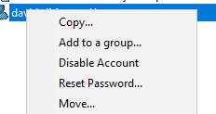

Figure 11 To disable account/ make account inactive

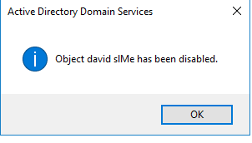

Figure 12 Account has been disabled

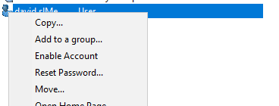

Figure 13 To enable account after one-month leave

Adding computer policy for accounting department.

Open Group Policy Management from the server manager tools.

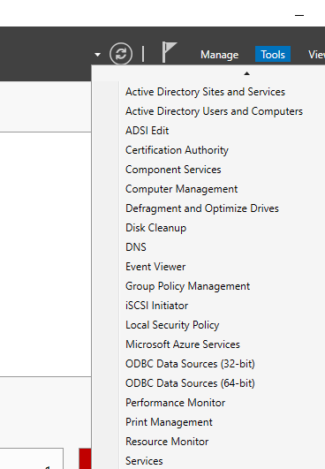

Then navigate to accounting unit in the window, right-click and add new GPO. I named it inactiviylock.

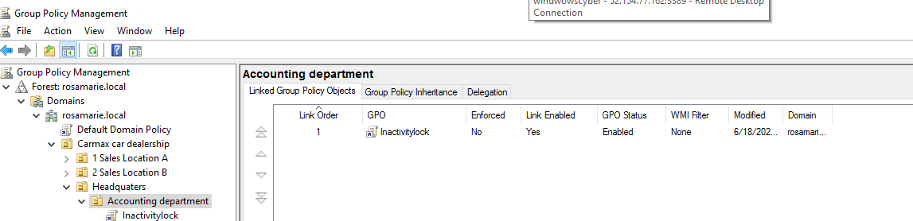

Then right-click on inactivitylock and edit. Under computer configurations, navigate to security options and search for Machine inactivity limit and select it.

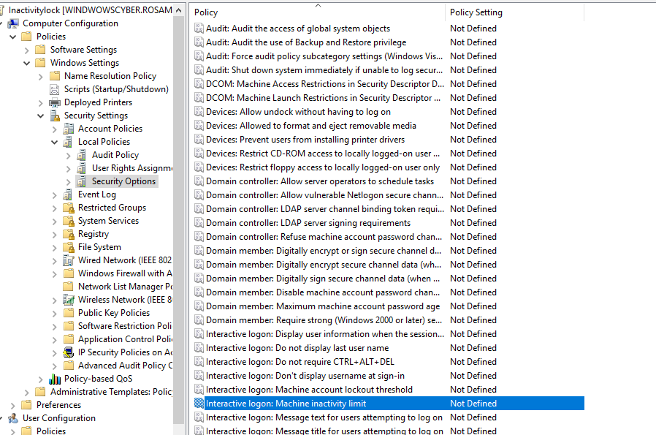

Set the time/limit to 3 mins (180 seconds)

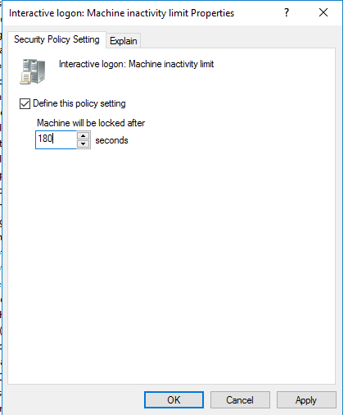

I closed group policy and open it again. Then went to inactivitylook to make sure the changes/policy has been set. This is proof from the window.

